9: Build and Manage a Linux Server

Task 1: Configure SSH Server

Step 1: Check Server IP
ip a
Note the server IP.

exiStep 2: Install OpenSSH
yum install openssh-server -y
Verify:
rpm -qa | grep openssh

Step 3: Start SSH Service
systemctl start sshd
systemctl enable sshd
systemctl status sshd

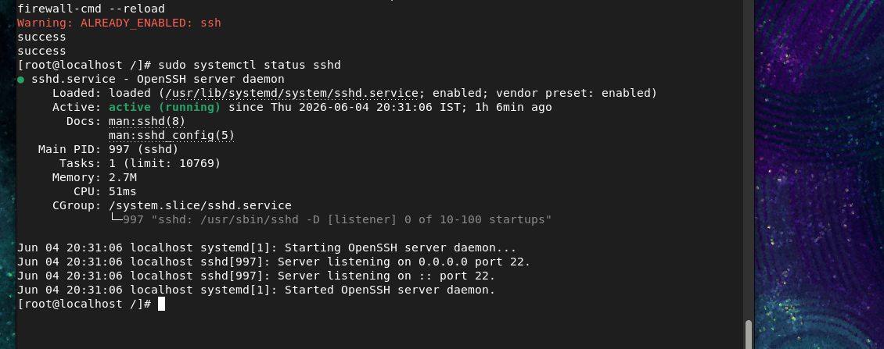
Expected:
active (running)

Step 4: Allow SSH Through Firewall
sudo firewall-cmd --add-service=ssh --permanent
sudo firewall-cmd —-reloadsc

Check:
sudo firewall-cmd --list-services
SSH should appear.
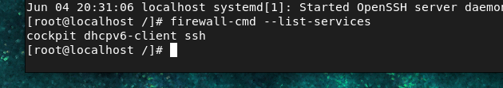

Step 5: Create User
sudo useradd student1
sudo passwd student1
Password:
redhat123
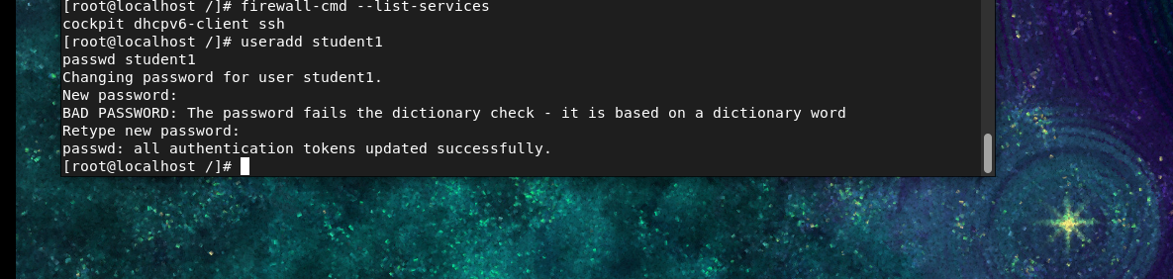

Step 6: Test SSH
From client:
ssh student1@192.168.1.100
Or PuTTY:
- Enter Server IP
- Click Open
- Login
Student can remotely access server.
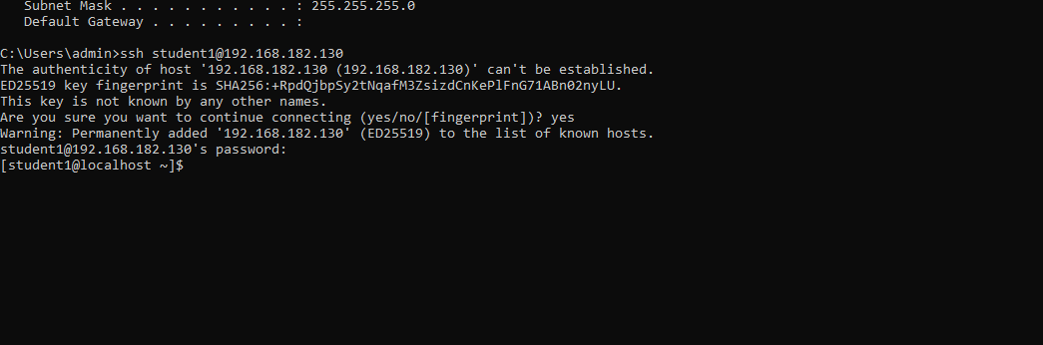

10. Linux Logs

What is a Log?
A log is a file that stores information about system activities, errors, logins, services, and events.

Log Directory
cd /var/log
ls

Important Log Files
Log File | Purpose
/var/log/messages | General system messages
/var/log/secure | Login and authentication records
/var/log/boot.log | Boot/startup messages
/var/log/maillog | Mail server logs
/var/log/dmesg | Hardware and driver messages
/var/log/cron | Cron job activities
/var/log/btmp | Failed login attempts
/var/log/wtmp | Login/logout history
/var/log/dnf.log | Package installation history
/var/log/httpd/ | Apache web server logs
/var/log/.log | MySQL database logs

11. Linux Networking

What is NetworkManager?
A service that manages network connections automatically.

Network Configuration File
/etc/sysconfig/network-scripts/

Task 3: Configure Networking

Step 1: Check Current Network
ifconfig
nmcli connection show

Step 2: Create New Network Profile
nmcli connection add \
type ethernet \
ifname ens160 \
con-name training \
ipv4.addresses 192.168.1.200/24 \
gw4 192.168.1.1 \
ipv4.method manual

Command Breakdown

1. nmcli
nmcli
- NetworkManager Command Line Interface.
- Used to manage network settings from the terminal.
Example:
nmcli connection show
Shows all network profiles.

2. connection add
connection add
Means:
Create a new network connection profile.

3. type ethernet
type ethernet
Specifies the network type.
Possible types:
ethernet
wifi
bridge
bond
vlan
Here:
ethernet = Wired Network

4. ifname ens160
ifname ens160
Specifies which network interface will use this profile.
Check interfaces:
ip a
Example output:
ens160
lo
Here:
ens160 = Network Card

5. con-name training
con-name training
Connection profile name.
You can choose any name:
con-name office
con-name staticip
con-name labnetwork
This creates:
Profile Name = training
Check later:
nmcli connection show
Output:
NAME
training

6. ipv4.addresses 192.168.1.200/24
ipv4.addresses 192.168.1.200/24
Assigns a static IP address.
Meaning:
IP Address = 192.168.1.200
Subnet Mask = /24
/24 equals:
255.255.255.0

7. gw4 192.168.1.1
gw4 192.168.1.1
Default Gateway.
Think of the gateway as:
The router used to reach other networks or the internet.
Example:
Computer → Gateway → Internet
Gateway:
192.168.1.1

8. ipv4.method manual
ipv4.method manual
Means:
Use manually configured IP settings.
Without this, NetworkManager may try DHCP.

Step 3: Activate Connection
nmcli connection up training
Verify:
ip a
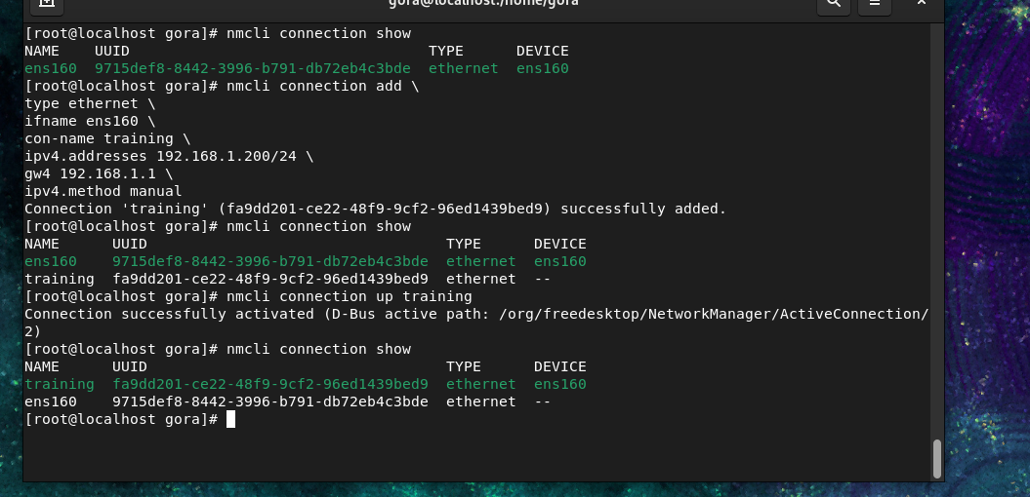

Step 4: To delete the ip
nmcli connection delete training

nmcli connection show

12. Archive and Compression

Archive File
Combines multiple files and folders into one file.

Compressed File
Reduces file size.

Step 1: Create Data
mkdir /project
cd /project
Create folders:
mkdir docs images videos
Create files:
touch docs/file1.txt
touch docs/file2.txt
touch images/img1.jpg
touch videos/video1.mp4
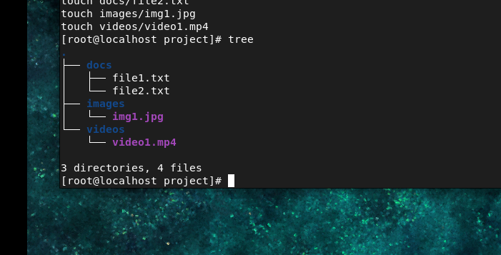

Check:
tree /project

Step 2: Create TAR Archive
tar -cvf backup.tar docs images videos

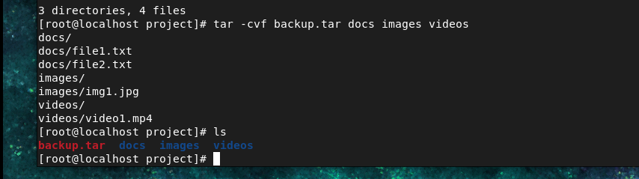
Verify:
ls –lh

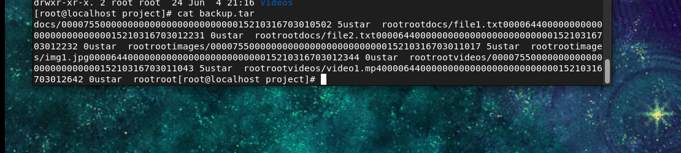

Step 3: View Archive Content
tar -tvf backup.tar
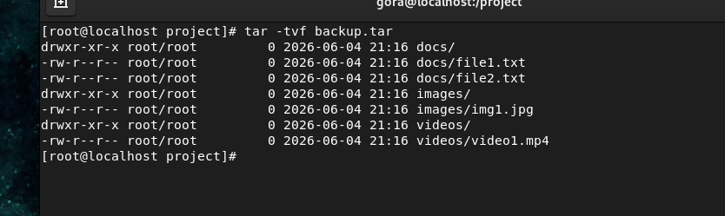

Step 4: Extract Archive
mkdir restore
tar -xvf backup.tar -C restore
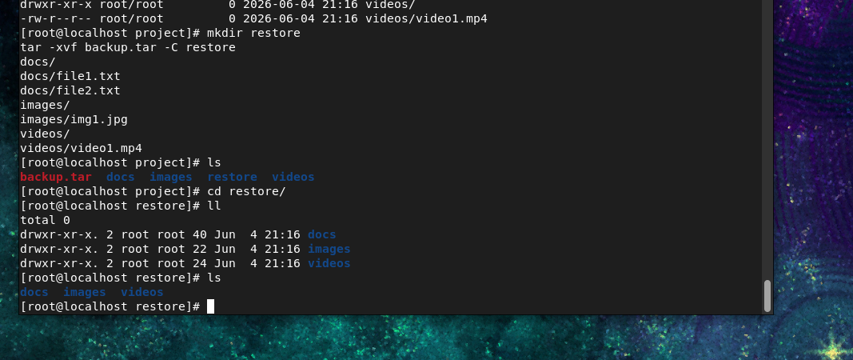
Verify:
tree restore

Task 5: Compress Backups

Gzip
Create:
tar -cvzf backup.tar.gz docs images videos
Check:
ls –lh
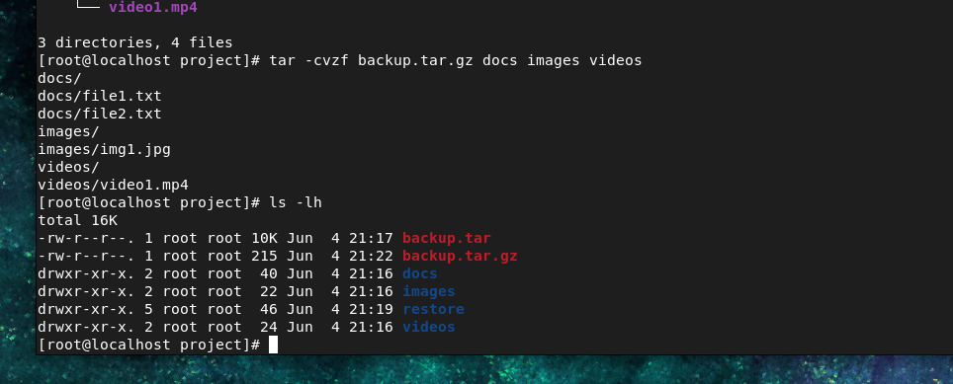

Extract
mkdir gzip_restore
tar -xvzf backup.tar.gz -C gzip_restore

cd /
sudo rm -rf /project/*

